Furkan KARAKAYA

1937051

EE564 – Project 1

DESIGN of ınductor and transformer

Project Report

Contents

INDUCTOR DESIGN 2

# INDUCTOR DESIGN

An inductor is a passive basic circuit component that is used in many applications. An inductor is constructed by wounding a cable around a magnetic core. The inductor specifications depend on the number of turns of wounding and magnetic characteristics of core. As a result, for different applications, different type of cores are preferred. In this study, a powder core, KoolMµ[1] from the Magnetics, is selected so that it might be used in a power electronics’ converter design, which requires higher energy storage capability. Contrary to other core types, powder cores are produced to store energy in the air gaps that exist in the core. Including the air gaps inside the core, the permeability range of the powder cores tend to be small, so the relative permeability of the selected core, 0077620A7, is 125 for the linear region. As shown in Figure 1, the B-H curve is obtained using the curve-fitting parameters given by manufacturer[2] and they can be seen in (1).

Figure 1: B vs H curve

$\%Initial Permeability=\frac{1}{0.01+6.345E-5*H^{1.462}}$ (1)

Figure 2: Relative Permeability vs H curve

Using the Figure 1, the point where the magnetic field strength is equal to 10 AT/cm is assumed as the end of the linear region. Also it is assumed that the rated DC current is 4A. Therefore, the required number of turn to operate in that point is calculated by eqn. (2) and it is 36.

$$N=\frac{H*l_{middle}}{I_{dc}} (2)$$

## PART A – Analytical Calculations

In the analytical calculations, the inductance for the cases linear & homogeneous core, linear & nonhomogeneous core, nonlinear & homogenous core and nonlinear & nonhomogeneous core is calculated.

To begin with, in these four different cases, the nonlinear & nonhomogeneous core is the most realistic one. However, it is also the most complex one to solve analytically. The linear core means that the core is never saturated which results from the constant permeability. Therefore, for linear core calculations the relative permeability is taken as 125 in this study. On the other hand, the permeability vs H curve, given in Figure 2, is used as a reference for nonlinear core calculations. Furthermore, the homogeneous core assumption is based on the same amount of flux flow in the core from innermost circle to the outermost circle. Thus, this assumption claims the arbitrary circles in the toroid core have the same reluctance. However, in reality, the innermost circle has the lowest reluctance, so the magnetic field strength is higher in the innermost circle than the others, which results in the possibility of the saturation in the inner circles of the core.

In analytical calculation, the core is discretized, and for each circle, the reluctance is calculated using the eqn. (3). Then, the resulting total reluctance is calculated by paralleling them.

$$R=\frac{l}{μ*A} (3)$$

For each cases, the basic induction calculation strategy is finding the equivalent reluctance and then the induction is calculated using the eqn. (4) and the results are provided in Table 1.

$$L=\frac{N^{2}}{R} (4)$$

|  |  |  |  |
| --- | --- | --- | --- |
| Linear | Homogenous | Current (A) | Inductance(µH) |
| ✓ | ✓ | 4 | 509 |
| ✓ | ✕ | 4 | 521 |
| ✕ | ✓ | 4 | 430 |
| ✕ | ✕ | 4 | 436 |
| ✓ | ✓ | 6 | 509 |
| ✓ | ✕ | 6 | 521 |
| ✕ | ✓ | 6 | 382 |
| ✕ | ✕ | 6 | 386 |

Table 1: Analytically calculated inductances when N is 36

In order to observe the differences among the cases, the inductance vs turn number and inductance vs excitation current graphs are plotted as shown in Figure 3 and 4. In both Figure 3 and 4, it is seen that the inductance result deviation is higher for linear and nonlinear cores whereas the homogeneity changes inductance minimally. Therefore, it can be deduced that the inductance homogenous inductance calculation is a useful approximation. On the contrary, the results are significantly different with respect to the linearity. In Figure 3, we observe that the inductance increases as expected for increasing turn number. This relationship was explained in Eqn. (4). In addition, it is seen that for lower turn numbers, the inductances of linear core and nonlinear core calculations overlap as expected but increasing the turn number since the core starts to be saturated slightly, the results become different. However, we observe the inductance increases in each case when the turn number is increased. On the other hand, when the excitation current is increased keeping the turn number constant, the inductance becomes smaller because the core is saturated so the reluctance is high. Increasing the current only saturates the core so it affect the inductance indirectly. This effect is not seen when the core is linear.

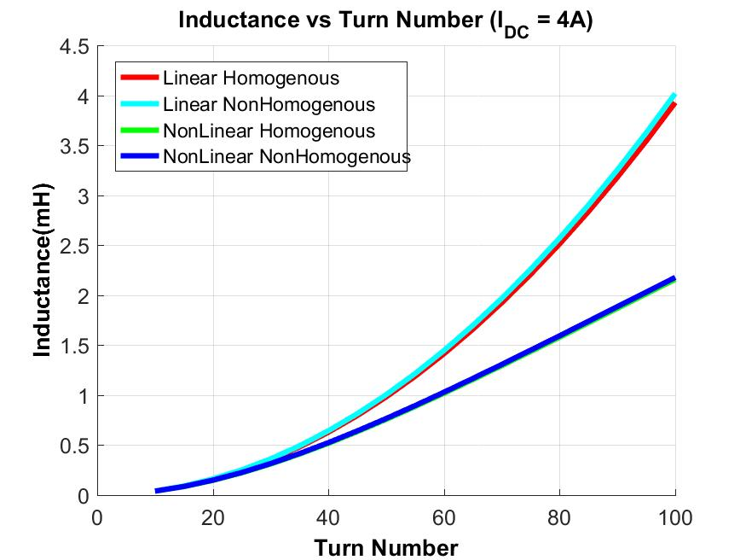

Figure 3: Inductance vs Turn Number

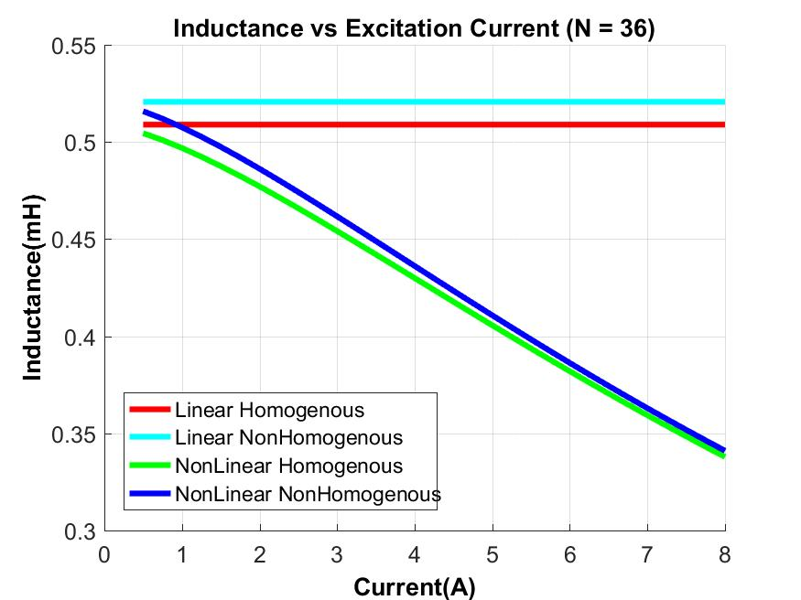

Figure 4: Inductance vs Excitation Current

When the air gap introduced, the equivalent reluctance increases significantly because the air has the lowest permeability, which shows a material magnetic opacity. Therefore, when the air gap exists, the inductance is much lower. Another concept is the leakage inductance which is there are fluxes around the gap with decreasing amplitude as it goes away than the gap. Inevitably, the fringing exists because in air there are actually many paths for flux to flow. The flux follow each path with different amplitudes with respect to the reluctance that depends on the length and area. Therefore, if the fringing fluxes are not taken into consideration the resulting inductance calculation will be slightly lower than the case where the fringing is taken into account. It is because of the fact that the inductance shows how much flux is linked for the given current. Therefore, if the fringing flux is not counted it results in the lower flux linkage so the inductance. The fringing flux is illustrated in Figure 5.

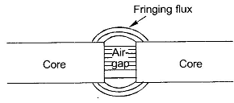

Figure 5: Fringing Flux Illustration

For estimation the effect of fringing, the method proposed in the Mohan’s book[3] is used. This method suggests to calculation of the air gap reluctance such that the axial length of the air gap is extended as gap length as shown in Figure 6.

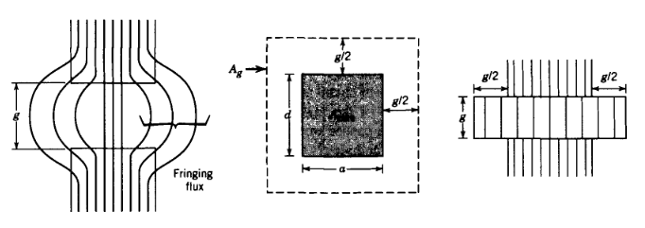

Figure 6: The method to estimate the effect of the fringing

Based on this method, the inductances are calculated as 178µH if the fringing does not exist and 194µH if the fringing exists.

## PART B – Finite Element Analysis

The finite element programs calculate the magnetostatic solution using the mesh networks. In this project, the toroid core is also analyzed in Maxwell software. The core is plotted in 2D and material B-H parameters are imported into Maxwell as a dataset. The conductors are modeled as circles inside & outside the core. Each conductor is excited with the current whose amplitude is rated current times turn number. The flux density distribution in the core and air is given in Figure 7. Since the core has constant permeability, it is not saturated and we see that the flux density increases up to 0.24 T inside the core. However, when the core is not linear, we observe the inner discs are saturated slightly, so they have higher reluctance, which reduces the flux density. It is also available in Figure 8.

When the air gap is introduced, we start to observe lower flux densities and fringing fluxes. The figures 9-12 shows the results for both linear core and nonlinear core with air gap.

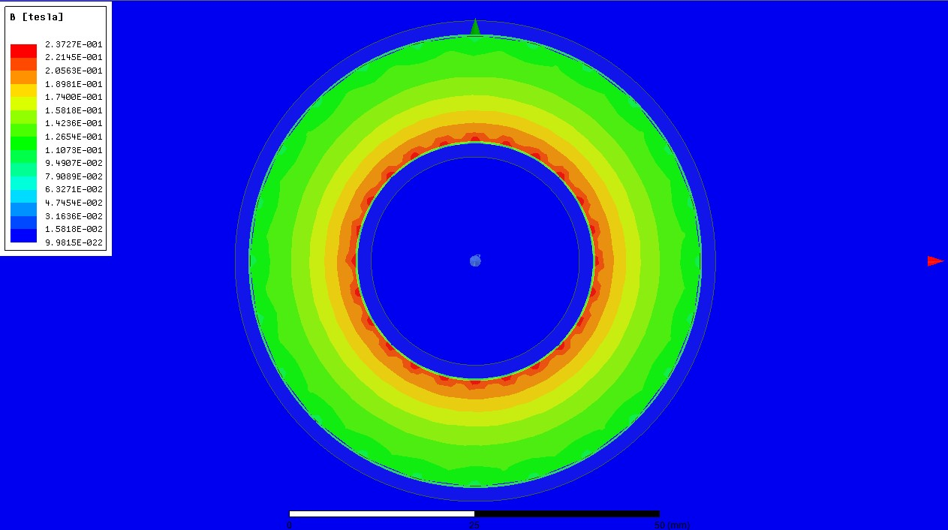

Figure 7: Flux Density for Linear Core

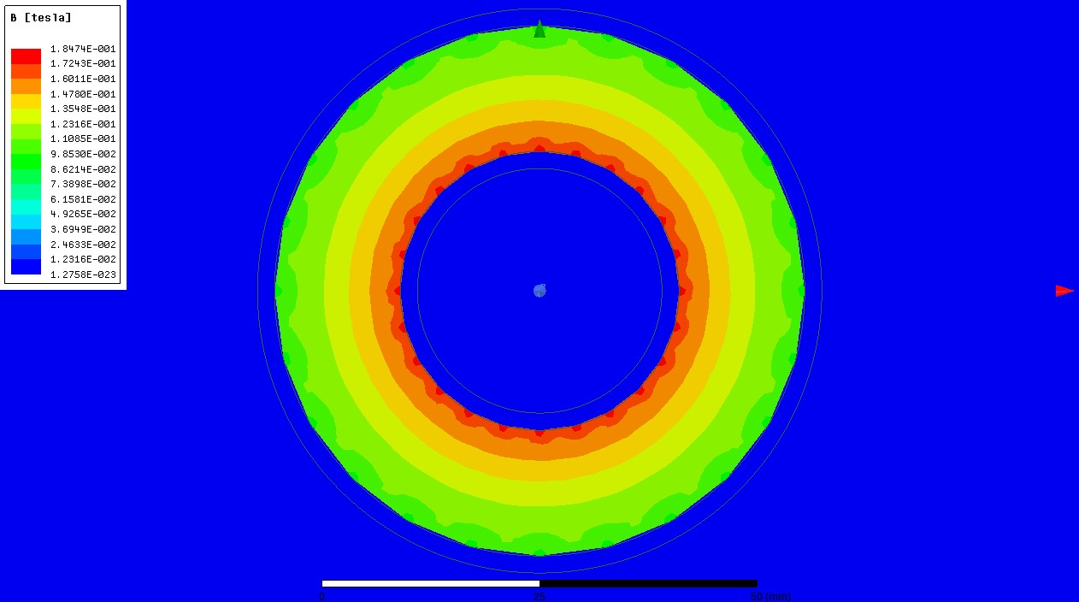

Figure 8: Flux Density for Nonlinear Core

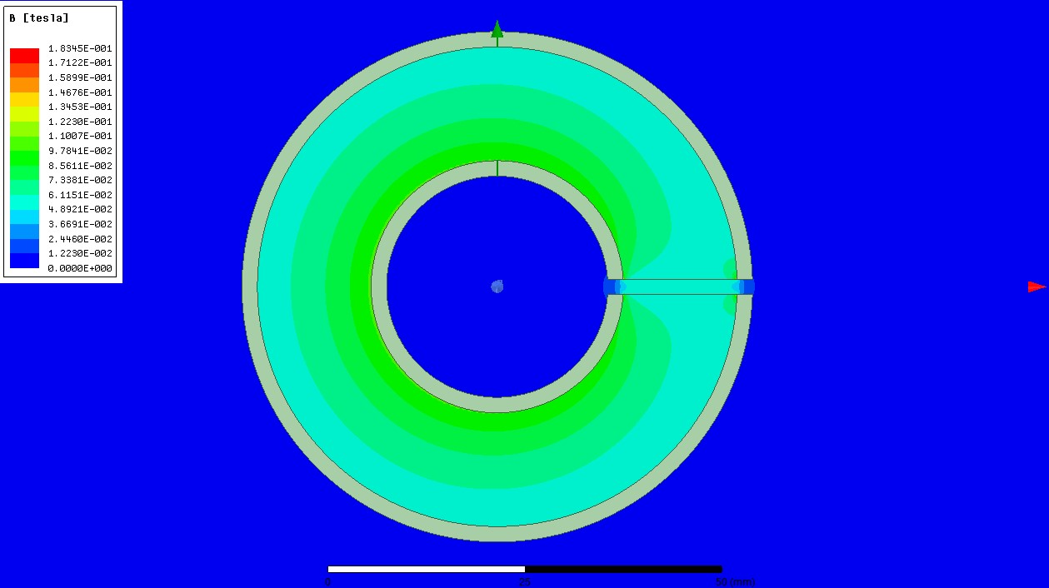

Figure 9: Flux Density for Linear Core with Air Gap

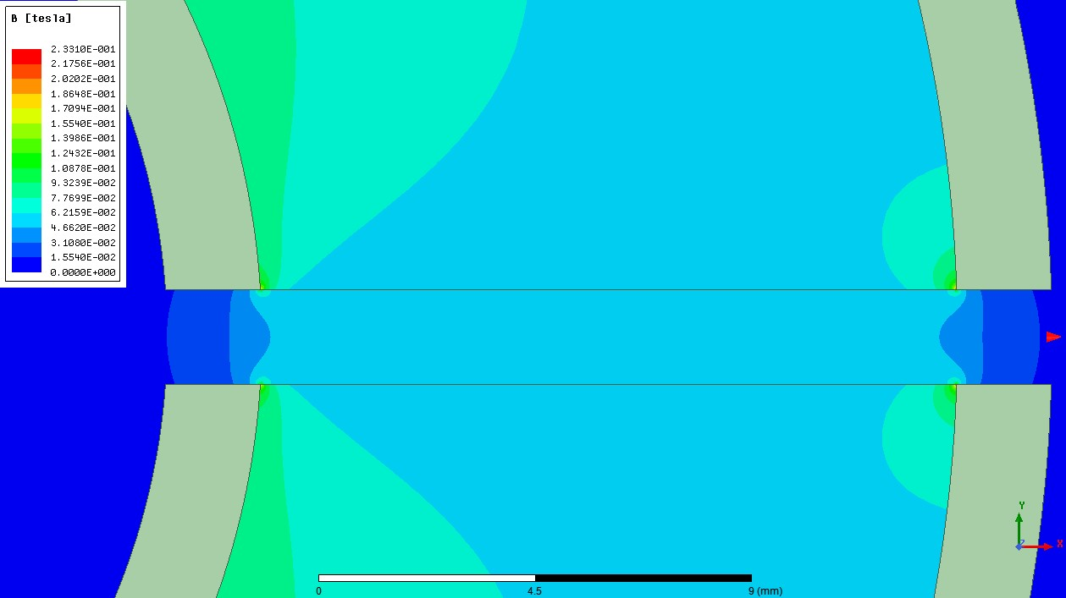

Figure 10: Flux Density around the Gap for Linear Core

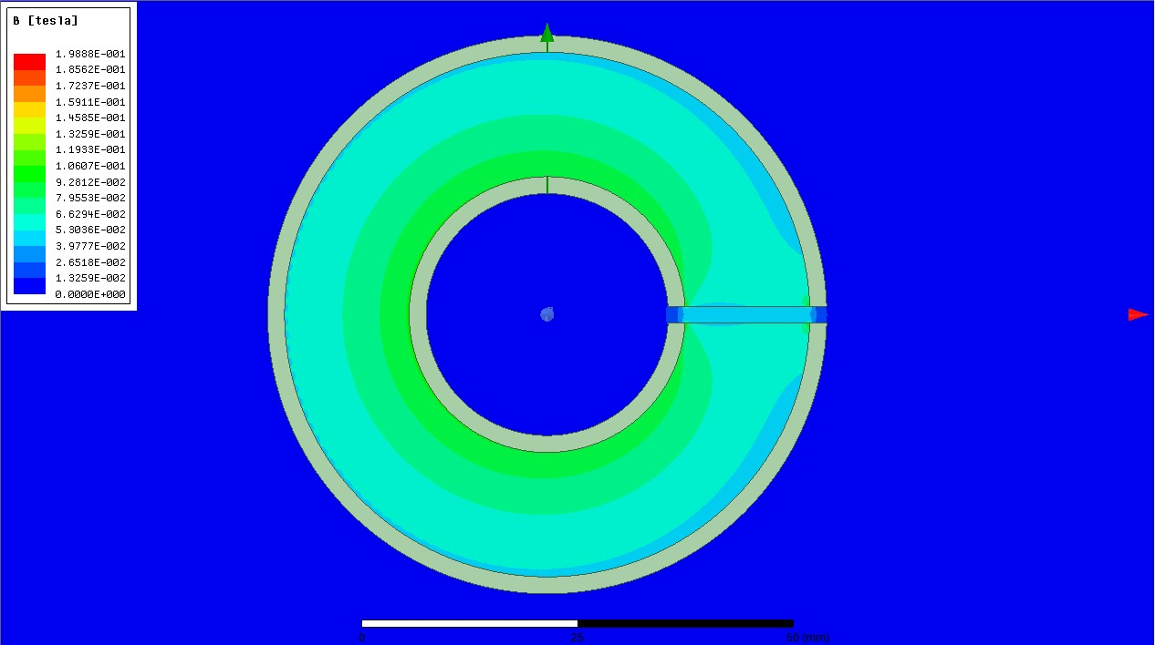

Figure 11: Flux Density for Nonlinear Core with Air Gap

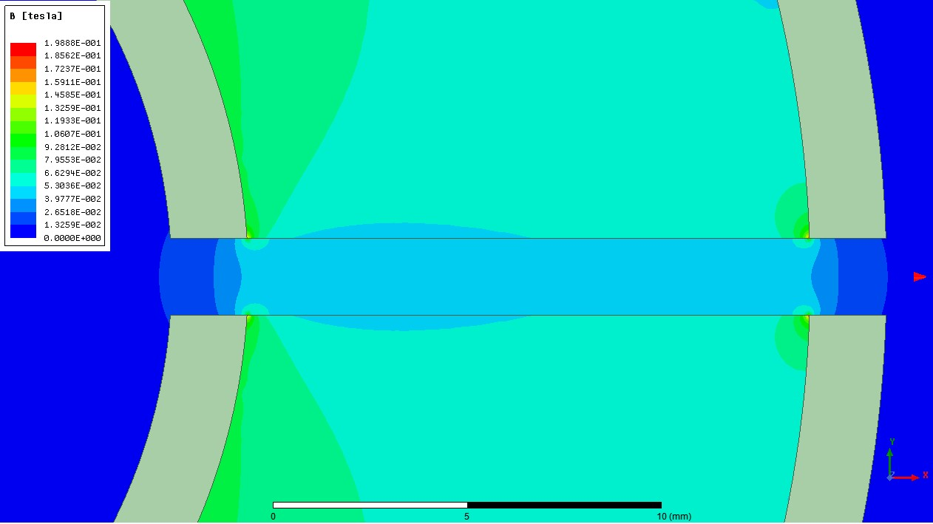

Figure 12: Flux Density around the Gap for Nonlinear Core

|  |  |  |  |  |
| --- | --- | --- | --- | --- |
| Linear | Air Gap | Mutual Ind. (µH) | Leakage Ind. (µH) | Total Ind. (µH) |
| ✕ | ✓ | 167 | 4 | 171 |
| ✓ | ✓ | 171 | 4 | 175 |
| ✕ | ✕ | 435 | 0 | 435 |
| ✓ | ✕ | 520 | 0 | 520 |

Table 2: Inductances Calculated in Finite Element Analysis

Inductance hesaplamalarından bahsedilecek, analitikle karşılaştırılma ypaılacak

3d analiz ile 2d analizin farkı anlatılacak

Trafo

1. <https://www.mag-inc.com/Media/Magnetics/Datasheets/0077620A7.pdf>
2. <https://www.mag-inc.com/Media/Magnetics/File-Library/Product%20Literature/Powder%20Core%20Literature/2017-Magnetics-Powder-Core-Catalog.pdf?ext=.pdf>
3. Power Electronics, Ch. 30, P.758, Figure 30-10